**PART A**

(Part A: TO BE REFFERED BY STUDENTS)

**A.1 AIM:**

Develop a web based Mini Project

**A.2 Pre requisite:**

Basic Knowledge of HTML, CSS, JavaScript, Server Side Scripting, JQuery, Bootstrap, PHP, Browser.

**A.3 Outcome:**

After successful completion of this experiment students will be able to:

1. Design a website using various web programming languages learnt.

**A.4 Theory:**

A mini project is desirable to be completed by a group of two or three students that cover

following tools.

HTML

DHTML

CSS

Java Script PHP

Bootstrap

JQuery

**A.5 Procedure/Task:**

1. Develop a website using Web technologies learnt.
2. The site should be attractive & interactive.
3. Prepare the document. Save and close the file and name it as RollNo._MiniProject.

**PART B**

(PART B: TO BE COMPLETED BY STUDENTS)

(Students must submit the soft copy as per following segments within two hours of the practical. The soft copy must be uploaded on the Blackboard or emailed to the concerned lab in charge faculties at the end of the practical in case the there is no Black board access available)

|  |  |
| --- | --- |
| Roll No. :C005 | Name: Kalash jain |
| Class :B | Batch : 1 |
| Date of Experiment : | Date/Time of Submission : |
| Grade : |  |

**B.1 Project Details**

*(Detailed description of project. It should include answers to following questions)*

*1) Motivation to take the proposed project*

*2) Scope of the project*

*3) Working of project*

*4) Advantages & disadvantages of project*

*5) Technologies used for developing the project*

**1) Motivation to Take the Proposed Project**

The motivation for launching a jewelry website stems from the increasing demand for online shopping, particularly in the jewelry sector, where customers seek convenience, variety, and unique designs. The project aims to provide a user-friendly platform that showcases a diverse range of jewelry items, including rings, bracelets, and necklaces, while enhancing customer experience through collaboration with established brands. By leveraging online sales, we can reach a broader audience, foster brand loyalty, and offer customers a seamless shopping experience.

**2) Scope of the Project**

The scope of the project encompasses the following:

**Product Catalog**: Displaying a wide range of jewelry items such as rings, bracelets, and necklaces with detailed descriptions, pricing, and high-quality images.

**E-commerce Functionality**: Implementing a secure and efficient shopping cart system, payment gateways, and customer account management.

**Brand Collaborations**: Highlighting partnerships with other jewelry brands to offer exclusive collections, which will attract diverse customers.

**User Engagement**: Incorporating features like customer reviews, wish lists, and newsletters to foster interaction and retention.

**Responsive Design**: Ensuring the website is mobile-friendly to accommodate users across various devices.

**3) Working of the Project**

**User Interface**: Visitors can navigate through a well-structured menu showcasing different jewelry categories.

**Product Details Page**: Each item will have a dedicated page featuring detailed descriptions, multiple images

**4) Advantages & Disadvantages of the Project**

**Advantages:**

**Wider Reach**: An online platform allows access to a global audience, increasing potential sales.

**Convenience**: Customers can shop from the comfort of their homes, which enhances user experience.

**Brand Collaborations**: Partnering with other brands can attract new customers and enhance credibility.

**Diverse Product Range**: Offering various jewelry items meets different customer preferences and increases sales opportunities.

**Disadvantages**:

**Competition**: The online jewelry market is highly competitive, requiring strong marketing strategies to stand out.

**Operational Challenges**: Managing inventory, shipping, and customer service can be complex.

**Dependence on Technology**: Technical issues or website downtime can affect sales and customer satisfaction.

**Security Concerns**: Protecting customer data and financial transactions is critical and requires robust security measures.

**5) Technologies Used for Developing the Project**

The following technologies will be utilized for the development of the jewelry website:

**Web Development Frameworks**: Using frameworks such as React or Angular for a responsive and dynamic front-end experience.

**E-commerce Platforms**: Implementing platforms like Shopify or WooCommerce to manage product listings, shopping carts, and transactions.

**Payment Gateways**: Integrating secure payment solutions like PayPal, Stripe, or Razorpay for seamless transactions.

**Database Management**: Using MySQL or MongoDB for storing product information, customer data, and order history.

**Responsive Design Tools**: Utilizing CSS frameworks like Bootstrap for mobile-friendly design.

**Analytics Tools**: Implementing Google Analytics to track user behavior and optimize marketing strategies.

**B.2 Output**

*Page1:*



*Page 2:*

*Pg3*

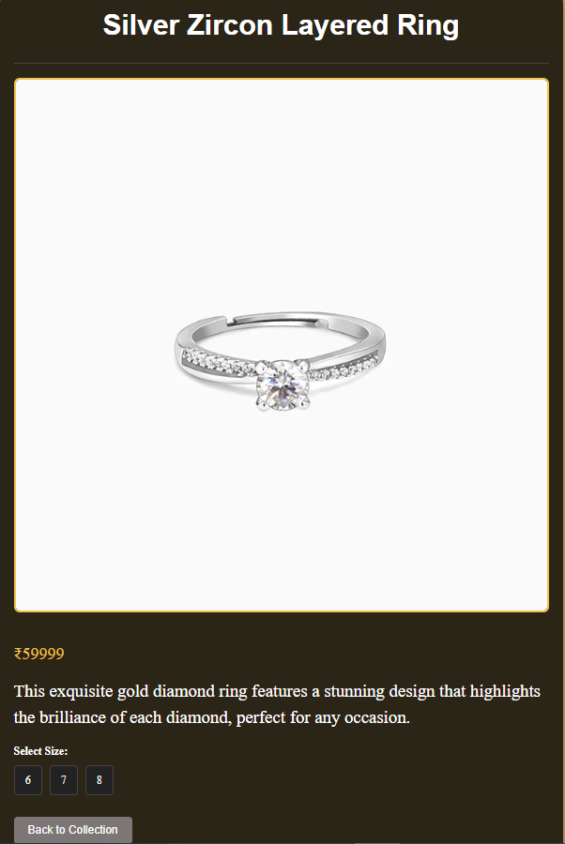*Pg*

**Pg5*

*Pg6:*

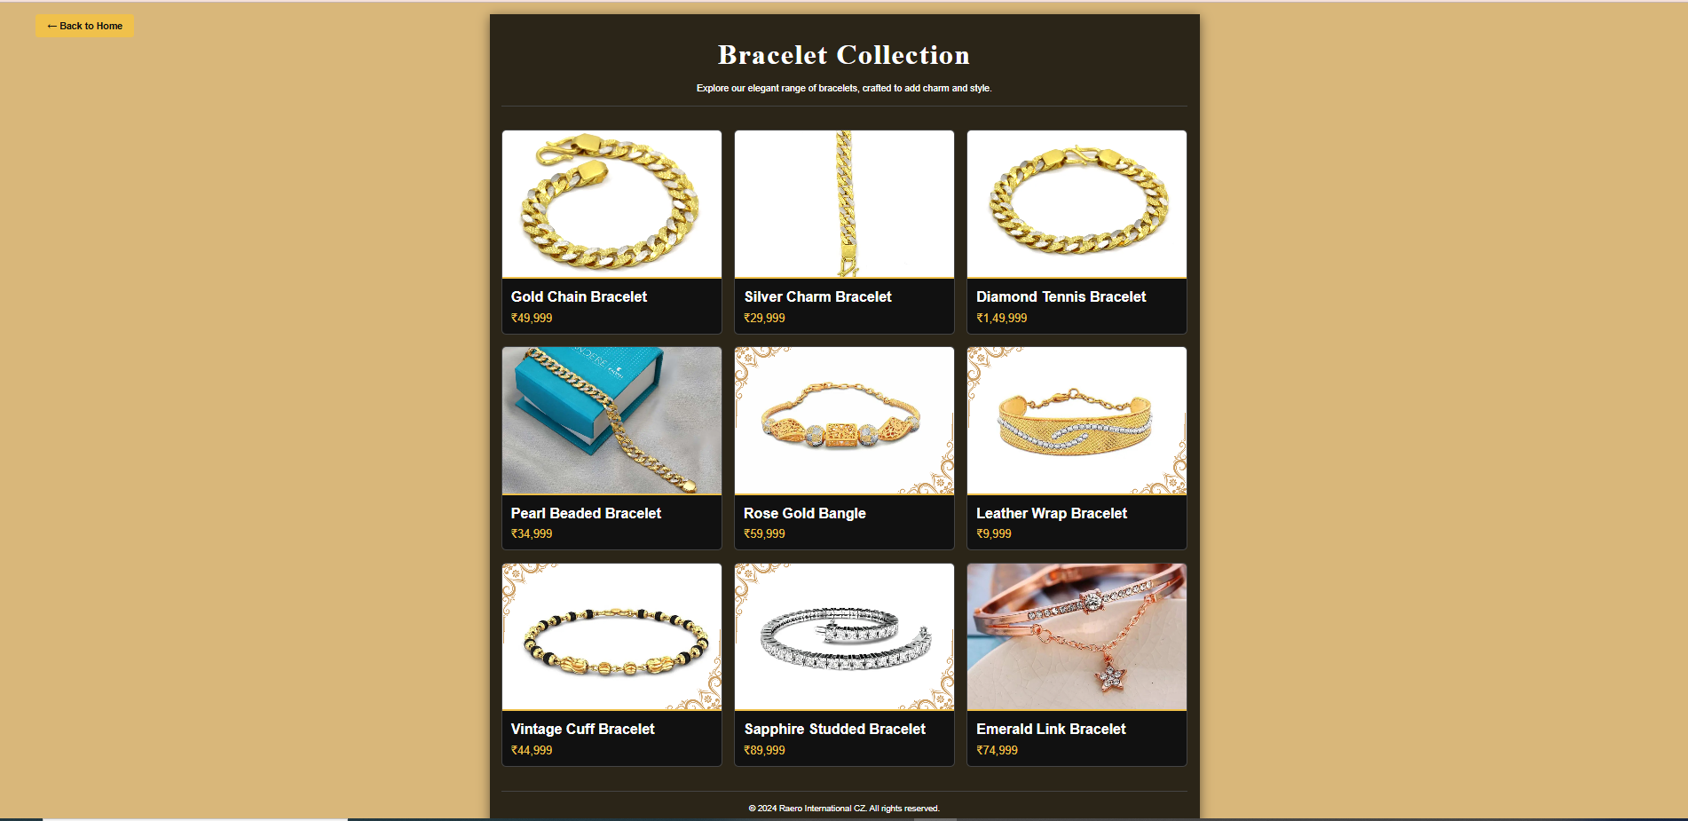

*Pg8:*

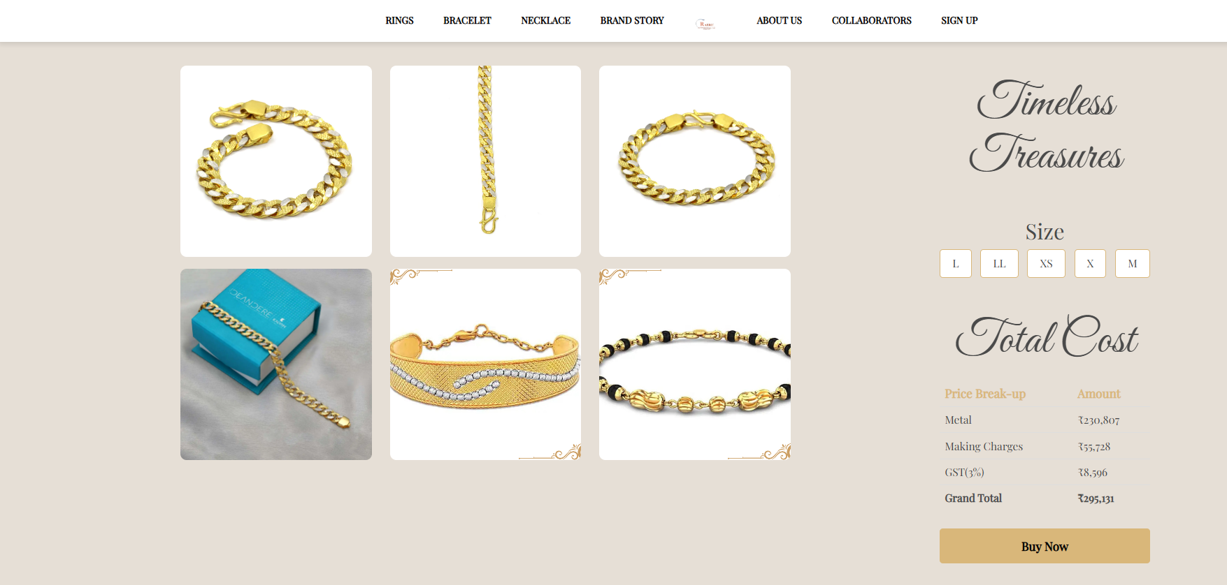

*Pg9:*

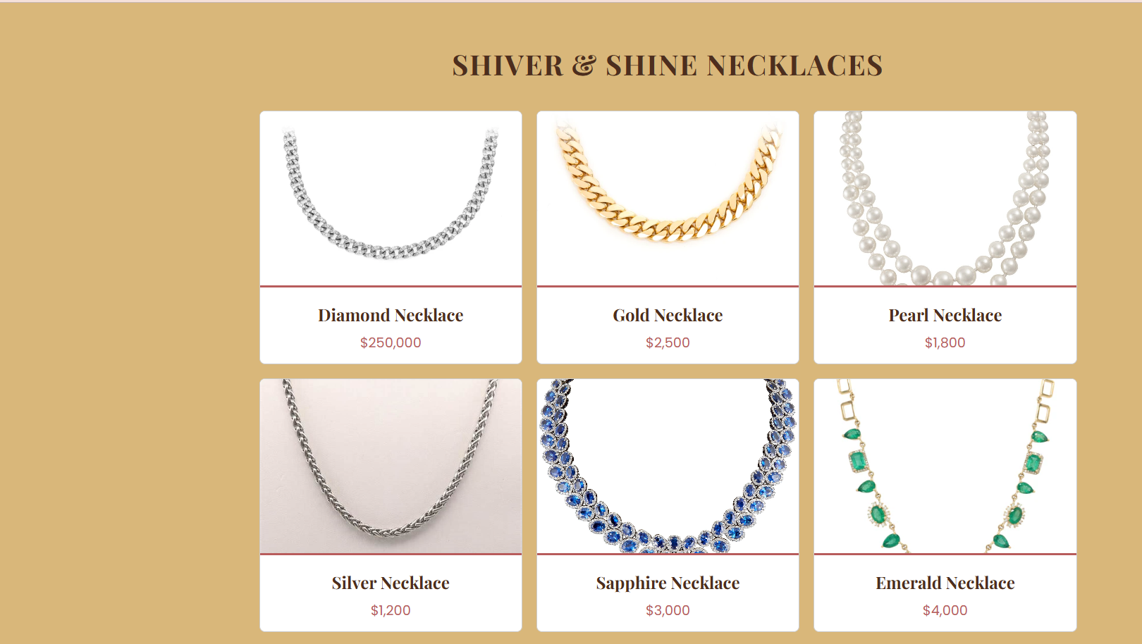

*Pg10:*

*Pg11:*

*Pg12:*

*Pg13:*

*Pg14:*

*PG15;*

**B.3 Conclusion:**

*(Students must write the conclusion as per the attainment of individual outcome listed above)*

**B.4 Observations and Learning:**

*(Students must write their observations and learnings as per the attainment of individual outcome listed above)*